1.
a)actual:0.192259
from newton-cote:0.192245

b)actual:-0.17682
from newton-cote:-0.17682

2.
Using newton-cotes:
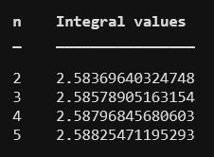
a)

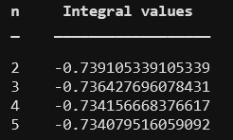
b)

3.
Using Gaussian quadrature:
a)n=2:0.66584
n=4:0.66349

b)n=2:1.963
n=4:1.9334

4.
Using Gauss-Legendre quadrature:
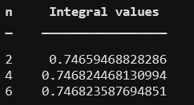
a)

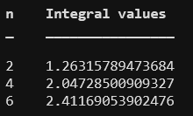
b)

